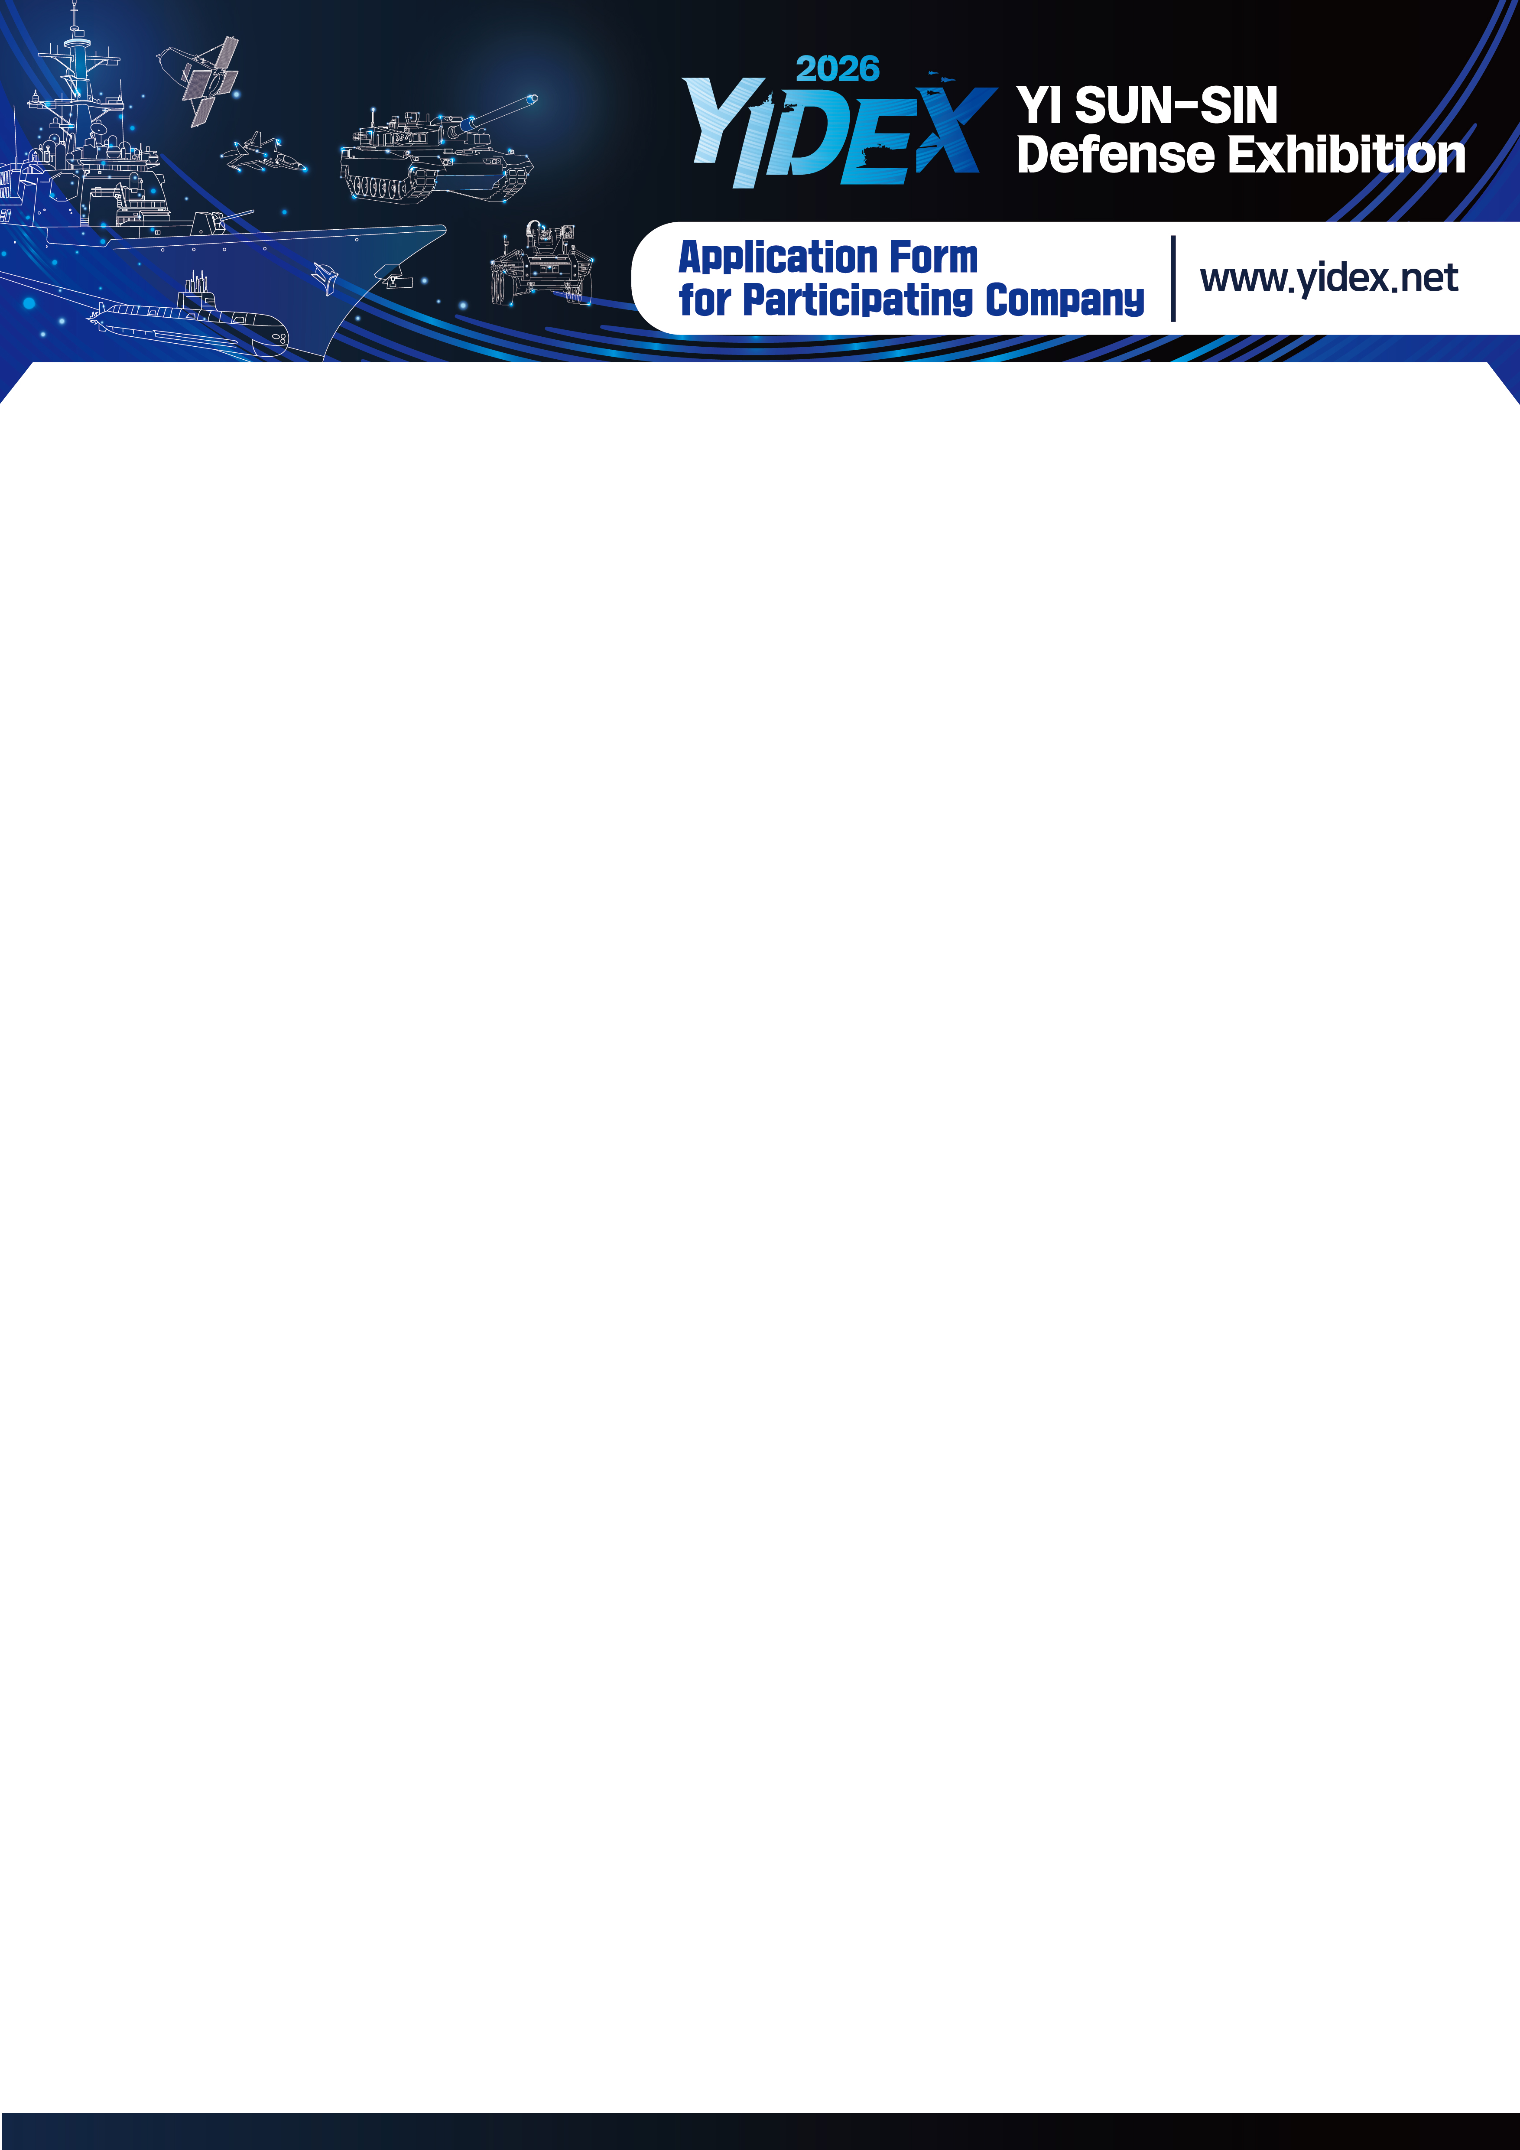

To | YI SUN-SIN Defense Exhibition Secretariat | Tel : +82-55-602-1993 Fax : +82-505-361-9609
To | YI SUN-SIN Defense Exhibition Secretariat | E-mail : expo0430@naver.com
1. Company Information ※ Please attach a copy of your business license when submitting the contract
Exhibitor Information | Company Name | Korean: | Representative
Exhibitor Information | Company Name | English: | Products for Exhibition
Exhibitor Information | Tel. |  | Email
Exhibitor Information | Business License No. |  | Fax
Exhibitor Information | Address | Korean:
Exhibitor Information | Address | English:
Contact | Dept.: Title: Name: Tel. (Cell):
Exhibition Hall | □ Defense Industry Exhibition Hall
2-1. Offline booth application and contract (Free admission to online exhibition halls when applying for offline booths)
Selection of Booth Type |  | □ Basic Booth  (Width · Length · Height) 3×3×2.4m | □ Independent Booth (Area Only)  (Width · Length) 3×3m
 |  | 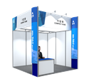  * The design is subject to change | 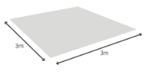  Exhibition area only
 |  | Includes 1 sign board, 1 information desk/1 chair, 3 spotlights, 1 power outlet (2 sockets), and 1kW of power | *Design and installation expenses are borne by the exhibitors
Booth Application Details | Price  (excluding VAT) | KRW 2,900,000 / Booth | KRW 2,400,000 / Booth
Booth Application Details | Number of Booths | ( ) Booths | ( ) Booths
Booth Application Details | Price | KRW ( ) | KRW ( )
Discount |  | - Early-bird discounts: KRW 500,000 per booth *Must apply by 31th Jan, 2026  - Re-participation discounts: KRW 200,000 per booth  * Available for participants in the 2019 Changwon Marine Defense Exhibition or the 2020 or 2022 or 2024 Yi Sun-Sin Defense Exhibition  *Multiple discounts are available/VAT included

2-2. Additional offline amenities (optional)
* Please submit a separate additional facility application after you have submitted your application for participation.
Additional facilities (optional) | Classification |  | Price (excluding VAT) | Remarks
Additional facilities (optional) | Electricity | Single-phase 220V  (For lighting/power) | KRW 60,000/kW | 1 kW free for each  Booth. Please  request if you need  more than that
Additional facilities (optional) | Electricity | 24 hours | KRW 90,000/kW

3-1. Online booth application and contract (Free admission to online exhibition halls when applying for offline booths)
Booth Example | Exhibition Room | □ Marine defense & Unmanned system □ Weapons Systems □ IT and Security  □ Combat Support Supplies and Equipment
Booth Example | 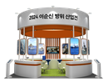 |  | 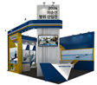 |  | 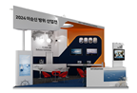
Booth Example | * Online booth types are randomly assigned
Included | ● Title: Company logo and name (in Korean and English)  ● Company profile page  - Company profile (100 characters – In Korean and English)  - Video upload (in Korean with English captions) - Link to website  - Company profile PDF file (in Korean and English) - Contact (in Korean and English)  ● Key technology & product information page  - Information (100 characters - In Korean and English)  - 5 product images - Product information PDF file (in Korean and English)  ※ Online booth – Design to be provided  ※ Materials to be prepared in different languages (Translation to be provided by exhibitors)
Price  (excluding VAT) | KRW 1,000,000 / Booth |  |  | KRW ( )
Price  (excluding VAT) | Re-participation (Content modification among existing participants): KRW 500,000/booth

3-2. Additional online amenities (optional)
* Please submit a separate additional facility application after you have submitted your application for participation.
Additional facilities (optional) | Classification |  | Price (excluding VAT) | Remarks
Additional facilities (optional) | Web graphics production | Per image | KRW 160,000
Additional facilities (optional) | Video production | Business promotional video production | To be discussed
Additional facilities (optional) | Product image | Taking image of product | To be discussed
Additional facilities (optional) | Homepage Banneer | Main Logo Exposed | KRW 2,000,000/  per image | If you click the logo,  go to Online Company Booth.

4. Person in charge of electronic tax invoices
Name |  | Tel.
E-mail

Payment | Account No. : 207-0178-5094-08 Kyongnam Bank Account Name : EDIA Co.,Ltd  Swift Code : KYNA KR 22
Payment
50%: Payment to the account above within 7 days after application (Please send a copy of transaction slip via email or fax.)
50%: To be transferred by 4th, Mar, 2026

Application Documents: Notification after application
Cancellation (Refund)
Within 7 days of notification of payment destination: 50% of the total price
30 Days before launch: 50% of Total Price
Date Month Day , 2026
I agree with the application form and rules. Representative : (Seal)
Person in Charge : (Seal)



Article 1 (Definition of Terms)
1. The term "Exhibitor" refers to any individual, company, association, or group that submits a specific application form to participate in the "2026 YI SUN-SIN Defense Exhibition (YIDEX 2026)". The "Exhibition" denotes the offline exhibition mentioned above.
2. The term "Host" denotes the organizing and hosting organizations of the exhibition.

Article 2 (Application and Contract)
To apply for participation in the exhibition, please complete the application form and submit it to the organizer. The exhibition participation contract will be considered established upon confirmation.

Article 3 (Assignment of Exhibition Area)
1. The host will confirm participation based on the application form and exhibition details and will assign exhibition positions accordingly.
2. If adjustments are necessary for the overall operation of the exhibition hall, taking into account spatial arrangement, visitor efficiency, and exhibition impact, the host reserves the right to change assigned exhibition positions. This decision rests solely with the host, and exhibitors are not permitted to raise objections.

Article 4 (Management of the Venue)
1. Exhibitors must display their exhibits in designated exhibition areas and assign staff to manage their respective booths.
2. If any exhibitor displays unspecified or inappropriate exhibits, engages in wrongful acts without authorization, or causes damage to other exhibitors, the host may require immediate suspension, removal, or adjustment of booths. The exhibitor will not be eligible for compensation.
3. The host reserves the right to control access to the venue as necessary.
4. Exhibitors may not transfer all or part of their assigned exhibition area to others without prior consent from the host.
5. Exhibitors are prohibited from altering the basic shapes of booths and facilities and must compensate the host for any damage to exhibition equipment, including restoration.

Article 5 (Payment of Participation Fee)
1. Exhibitors must submit application forms to the host.
2. The participation fee must be deposited within the time frame determined by the organizer.

Article 6 (Cancellation)
1. If any exhibitor rejects the use of all or part of their assigned booth or fails to comply with exhibition rules, the host may unilaterally cancel the contract.
2. To cancel the exhibition participation contract, exhibitors must submit a written cancellation form to the host at least 30 days before the exhibition launch.
3. In principle, exhibition participation contracts cannot be canceled within 30 days of the exhibition launch.

Article 7 (Cancellation or Change)
If the host cancels the exhibition, exhibitors will be notified in advance. However, separate notification will be provided if the exhibition is canceled, changed in terms of launch date, or reduced in size due to Force Majeure or any reason not attributable to the host. In such cases, exhibitors will not be eligible for compensation from the host.

Article 8 (Carrying Out System and Exhibits)
Exhibitors must carry in and display systems and exhibits within their respectively assigned exhibition areas and within the specified period.

Article 9 (Carrying Out Exhibits and Devices)
Exhibitors must carry out all exhibits and devices within the specified period and must cover any costs incurred by the host for delayed implementation.

Article 10 (Security, Risk, and Insurance)
1. The host will implement adequate security measures for the exhibitors and visitors.
2. Exhibitors will be solely responsible for any damage or theft of devices or exhibits within their assigned exhibition areas during the exhibition and removal periods.
3. If any exhibitor causes a fire, theft, damage, or any other accident intentionally or accidentally, they will be liable for compensating the host or any affected parties for the resulting damages. Exhibitors are also responsible for insuring their exhibits.

Article 11 (Fire Prevention Rules)
1. All devices and materials within the venue must be treated sufficiently to prevent inflammability in accordance with the Fire Services Act.
2. The host may require corrective actions from exhibitors to prevent fire hazards.

Article 12 (Additional Rules)
1. The host may establish additional rules as necessary.
2. Additional rules will be considered part of the participation rules, which exhibitors are required to adhere to.

Article 13 (Resolution of Conflicts)
Any disputes regarding the interpretation of these participation rules or the rights and obligations between the host and exhibitors will be arbitrated and adjudicated by the Korean Commercial Arbitration Board, and the arbitration decision or judgment will be final.



Article 1. (Definition of Terms)
1. The term "Exhibitor" refers to any individual, company, association, or group that submits a specified application form to participate in the 2026 Yi Sun-Sin Defense Exhibition (YIDEX 2026)". The “Exhibition” refers to the online exhibition mentioned above.
2. The term "Host" refers to the hosting and organizing organizations of the exhibition.

Article 2. (Application, Contract, and Payment)
1. Individuals wishing to apply for the exhibition must complete the designated application form and submit it to the organizer. The contract for participation in the exhibition shall be considered effective once approval is granted by the organizer after reviewing the details of the company submitted on
2. The participation fee must be deposited with the application form within the time frame specified by the organizer. However, even if the payment deadline specified in the application for participation applies, the full payment of the participation fee must not exceed 20 days before the opening.

Article 3. (Exhibition Area and Space Assignment)
1. The organizer assigns exhibition spaces after confirming participation based on the application form and exhibition contents.
2. If necessary for the smooth operation of the exhibition hall, taking into account spatial harmony, visitor efficiency, and overall exhibition effectiveness, the organizer reserves the right to reassign exhibitors to different exhibition spaces. This decision is at the organizer's discretion, and exhibitors are not entitled to appeal.

Article 4. (Registration and Use of YIDEX.NET)
1. Exhibitors will receive user privileges upon registration with yidex.net from the moment participation approval is granted until December 31, 2023.

Article 5 (Exhibition Venue and Content Management)
1. Exhibitors must provide exhibition contents by the designated date and cannot object to the nonconformity of the exhibition contents demonstrated after the specified date.
2. The deadline for providing exhibition contents to the organizer will be separately determined according to the application for participation. If not specified in the application, it will be announced.
3. If an exhibitor provides or displays content different from that specified in the application form, or content that does not conform to the nature of the exhibition, or engages in unfair acts without organizer permission or acts that harm other exhibitions, the organizer may suspend or delete the booth content immediately. The exhibitor cannot claim compensation as a result.
4. The organizer may restrict specific individuals from entering the exhibition hall if necessary.
5. Exhibitors are prohibited from assigning or transferring any part of the allotted exhibition space to third parties without written consent from the organizer.

Article 6 (Cancellation of Contract)
1. The organizer reserves the right to cancel a participation contract at its discretion if an exhibitor refuses to provide or showcase all or part of its exhibition contents in an allocated booth, or fails to adhere to the exhibition rules.
2. To cancel an online booth agreement, exhibitors must submit a written cancellation request to the organizer within 10 days of application.
3. In principle, contracts for exhibition participation shall not be cancelled once approval for participation is granted.

Article 7. (Cancellation or Change of Exhibition)
The organizer will provide prior notice of any exhibition cancellation to the exhibitors, if applicable. However, separate notice will be provided if the exhibition is cancelled or its launch date is changed due to special conditions beyond the organizer's control, including natural disasters and other types of force majeure. In such cases, exhibitors will not be entitled to compensation from the organizer.

Article 8. (End of Exhibition)
The organizer will conclude the demonstration of exhibition contents at the end of the exhibition. However, the organizer reserves the right to extend the period if deemed necessary.

Article 9. (Information Security, Risk, and Insurance of Exhibition)
1. The organizer will implement reasonable information security measures for exhibitors and visitors.
2. If an exhibitor causes intentional or unintentional information security incidents resulting in damages to the organizer or others, the exhibitor will be solely responsible for compensation, and exhibitors are required to insure their exhibition contents for information security.

Article 10. (Supplementary Rules)
1. The organizer may establish supplementary rules as necessary.
2. Supplementary rules will be integrated into the participation rules, and exhibitors are obligated to adhere to them.

Article 11. (Resolution of Disputes)
Any disputes regarding the interpretation of the participation rules or the rights and duties of the organizer and exhibitors will be subject to arbitration and judgment by the Korean Commercial Arbitration Board, and the judgment will not be submitted to any court.

